Chapter 7, Solution 78.

- When the switch is in position (a), the schematic is shown below. We insert IPROBE to display i. After simulation, we obtain,

i(0) = 7.714 A

from the display of IPROBE.
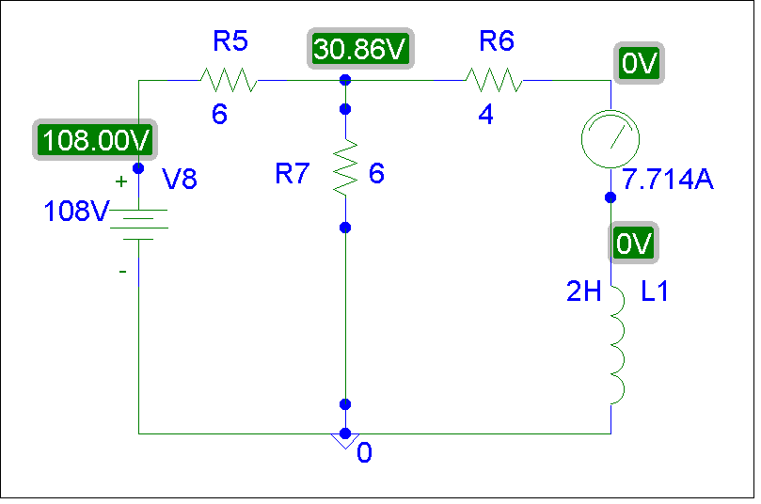

(b) When the switch is in position (b), the schematic is as shown below. For inductor I1, we let IC = 7.714. By clicking Analysis/Setup/Transient, we let Print Step = 25 ms and Final Step = 2 s. After Simulation, we click Trace/Add in the probe menu and display I(L1) as shown below. Note that i(∞) = 12A, which is correct.

